***Ex 1 LED FLASHER***

**Circuit Diagram**

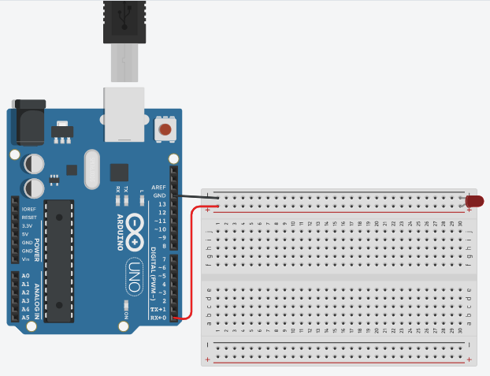

**Theory**

Concept Used:

Concept used in this is

1. Arduino UNO board coding
2. Arduino UNO board using
3. Breadboard using
4. LED using
5. LED diode junctions.

Learning & Observations:

1. I learned to make a LED flasher.
2. Using basic code in Arduino UNO IDE.
3. I observed the power of Arduino UNO basic information regarding Arduino Uno coding.

Problems & Troubleshooting:

I did not find any major problem in doing the task, however I did happen to come by a fused LED, making me take a few minutes more than I would have otherwise taken.

Troubleshooting for the same was just getting another LED.

Precautions

1. Do not directly connect the LED otherwise it will get fused.
2. Make sure all connections are tight and secure.
3. Ensure that the code is not only verified or compiled but is also uploaded on the board.
4. Check all the pin modes required are correct or not.
5. Make sure you are connecting the LED the right way.

Learning Outcomes

We learn to code and how to make circuit using Arduino board